**Chapter 1**

**INTRODUCTION**

In our fast-paced digital age, where technology permeates every aspect of our lives, cybersecurity emerges as a vital necessity. As our world becomes more interconnected, with reliance on digital platforms reaching unprecedented levels for businesses, governments, and individuals alike, the need for robust cybersecurity measures is nothing short of imperative. A primary driver behind the critical importance of cybersecurity is its role in protecting sensitive information. In an era where data is akin to currency, organizations and individuals store a wealth of confidential information online, spanning personal details, financial transactions, and proprietary business data. Cybersecurity acts as a bulwark against unauthorized access, ensuring the security of this valuable data and guarding against threats such as hacking, identity theft, and data breaches.

The scope of the digital realm extends beyond individual users and organizations to the national level, encompassing critical infrastructure and government systems. Cybersecurity, therefore, plays a pivotal role in safeguarding national security. Governments invest significantly in cybersecurity to shield sensitive military, intelligence, and infrastructure data from threats originating from state-sponsored actors, hacktivists, or cybercriminal organizations. Cyberattacks have the potential to inflict substantial financial losses on both individuals and organizations. Ransomware attacks, banking fraud, and various other forms of cybercrime can lead to significant monetary setbacks. Robust cybersecurity measures, including firewalls, antivirus software, and intrusion detection systems, act as a frontline defense against such threats, mitigating the risk of financial devastation.

As society increasingly relies on digital platforms for communication, commerce, and information exchange, preserving public trust in these systems becomes paramount. Cybersecurity breaches erode this trust by exposing vulnerabilities and compromising the integrity of online spaces. Building and maintaining public trust in digital technologies

necessitates effective cybersecurity measures, providing assurance to users that their interactions in the digital realm are secure and protected.

The dynamic and ever-evolving nature of cyber threats necessitates constant adaptation and innovation in cybersecurity practices. Effective defense against these threats requires collaborative efforts from governments, businesses, and individuals to stay ahead of cybercriminals and ensure the ongoing security of our digital infrastructure. In conclusion, the importance of cybersecurity cannot be overstated; it stands as the cornerstone of a secure and resilient digital future.

* 1. **Scope**

In the realm of modern communication, ensuring the security and integrity of messages exchanged over digital platforms has become paramount. The project at hand aims to address this critical need by developing a secure chat application that leverages Elliptic Curve Cryptography (ECC) with the FourQ curve. This innovative approach not only enhances the confidentiality of messages but also provides a robust framework for authentication and key exchange.

The primary objective of the project is to design and implement a chat application that offers end-to-end encryption using ECC with the FourQ curve. This encryption ensures that messages can only be accessed by the intended recipient, guaranteeing privacy and security. Additionally, the application will incorporate strong authentication mechanisms to verify the identity of users before granting access, further enhancing security measures.

One of the key features of the application is the implementation of the Diffie-Hellman key exchange protocol using ECC. This protocol allows users to securely exchange encryption keys without the risk of interception, ensuring that only the intended parties can decrypt and read the messages. Furthermore, the application will be optimized for performance, ensuring fast and efficient message delivery while maintaining high levels of security.

The user interface of the application will be designed to be intuitive and user-friendly, allowing users to easily send and receive messages, view chat history, and manage contacts. Cross-platform compatibility will also be a key focus, ensuring that the application can be used seamlessly across web, desktop, and mobile devices.

In terms of security measures, the application will incorporate robust safeguards to protect against common attacks such as eavesdropping, message tampering, and impersonation. Thorough testing and validation will be conducted to ensure that the application meets stringent security requirements and functions as intended.

Documentation will be a key deliverable of the project, providing comprehensive user guides and technical documentation for developers. This documentation will serve as a valuable resource for users and developers alike, ensuring that the application is easy to use and maintain.

In conclusion, the project aims to deliver a secure chat application that leverages ECC with the FourQ curve to provide a high level of security and privacy for users. By implementing strong security measures, optimizing performance, and providing a user-friendly interface, the application will offer a reliable and secure platform for communication in the digital age.

* **Performance Optimization**: Optimize the implementation further to decrease computational overhead and enhance efficiency in order to be able to support resource-constrained devices like IoT ones. Quantum computing could even speed up cryptographic operations hence a much faster performance of IoT devices.
* **Enhanced Security Features**: New security features may include post-quantum cryptography algorithms that can protect the chat app on IoT against emerging quantum attacks.
* **User Experience Improvements**: In order to allow for faster processing and responsiveness, speak about making the user experience better on IoT by including features like message delivery notifications, typing indicators, and message timestamps through which communication is allowed through quantum computing.
* **Cross-Platform Compatibility**: To make it usable and popular among different devices (including those of IoT platforms), the application should work with most of them in various operating systems.
* **Integration with Existing Systems**: Allow for the integration of this secure chat app to be done with present messaging platforms or through enterprise systems that utilize quantum computing features to enhance the security and efficiency of IoT gadgets.
* **Scalability**: This scalability design is such as one that makes use of quantum computing technology in order to do parallel processing hence making the application more scalable on IoT devices.
* **Compliance and Regulations**: Ensure that the application also adheres to other laws or regulations on data protection including those regarding IoT devices on quantum safe cryptography.
* **Research and Development**: The Application should be frequently updated with the latest advancements in quantum computing and quantum safe cryptography for IoT devices, thus we need to keep track of recent trends continuously.
* **User Education and Awareness**: Users utilizing these devices can benefit from being informed about what quantum computers mean, therefore providing them knowledge-based resources to understand it.
* **Feedback and Iteration**: Collect feedback from users and stakeholders to identify areas for improvement and iterate on the application to address any issues or concerns, including those related to quantum computing and IoT devices.

**1.2 Existing System**

In the rapidly evolving landscape of cybersecurity, the current cryptographic systems, while highly advanced, exhibit vulnerabilities that necessitate a paradigm shift towards more robust and efficient alternatives. The increasing computational power and evolving threat landscape have exposed weaknesses in existing cryptographic algorithms, highlighting the urgency for innovative solutions.   
One of the notable vulnerabilities lies in the conventional cryptographic systems' susceptibility to attacks leveraging quantum computing. As quantum computing capabilities continue to advance, traditional encryption methods, such as RSA and ECC (Elliptic Curve Cryptography), face an elevated risk of being compromised. The need for a cryptographic system resilient to quantum threats is more critical than ever.

To address this challenge, there is a growing consensus on the adoption of Elliptic Curve Cryptography (ECC) as a quantum-resistant solution. However, even within ECC, the efficiency of certain elliptic curves remains a concern. This problem statement specifically emphasizes the demand for a more efficient cryptographic solution, prompting the exploration of the FourQ equation. The FourQ equation, an innovative elliptic curve designed to enhance computational efficiency without compromising security, emerges as a promising alternative. Its unique properties offer a significant reduction in computation costs, making it an attractive candidate for real-world cryptographic applications. The adoption of FourQ not only addresses the inefficiencies of current cryptographic

systems but also positions organizations and systems to better withstand the imminent quantum threats.

In conclusion, the existing cryptographic infrastructure faces challenges that demand a proactive shift towards quantum-resistant solutions. The integration of Elliptic Curve Cryptography, specifically leveraging the FourQ equation, emerges as a strategic response to enhance efficiency and fortify cryptographic systems against the evolving threat landscape. This transition is not just a technological necessity but a crucial step in ensuring the long-term security and resilience of sensitive data in an increasingly interconnected digital world.

**1.3 Demerits of Existing System**

One of the notable vulnerabilities lies in the conventional cryptographic systems' susceptibility to attacks leveraging quantum computing. As quantum computing capabilities continue to advance, traditional encryption methods, such as RSA and ECC (Elliptic Curve Cryptography), face an elevated risk of being compromised. The need for a cryptographic system resilient to quantum threats is more critical than ever.

**Vulnerabilities to Quantum Computing**: Many existing cryptographic protocols rely on mathematical problems that are vulnerable to quantum computing attacks. With the potential advent of quantum computers, these systems could become obsolete, leading to a loss of security.

**Centralized Infrastructure**: Some secure chat systems rely on centralized infrastructure, which can be vulnerable to single points of failure, data breaches, or censorship by authorities.

**Limited Privacy**: Certain secure chat applications may collect metadata or store user communications, compromising user privacy. Additionally, metadata analysis can reveal patterns of communication, compromising anonymity.

**Lack of End-to-End Encryption**: Some communication platforms may not provide end-to-end encryption by default, leaving messages vulnerable to interception or decryption by third parties.

**Backdoor Risks**: In some cases, governments or regulatory bodies may pressure communication service providers to include backdoors for surveillance purposes, compromising the security of the entire system.

**Poor Key Management**: Inadequate key management practices can lead to key compromise or loss, jeopardizing the confidentiality and integrity of encrypted communications.

**User Authentication Weaknesses**: Weaknesses in user authentication mechanisms can result in unauthorized access to communication channels, leading to data breaches or impersonation attacks.

**Limited Interoperability**: Lack of interoperability between different secure chat applications or protocols can hinder seamless communication between users who use different platforms.

**1.4 Proposed System**

**Overview:**

The proposed system aims to create a secure chat application using Elliptic Curve Cryptography (ECC) with the FourQ curve. The system will include components for user authentication, key generation, message encryption, and performance analysis. It will utilize AES and SHA-256 for user authentication, Diffie-Hellman for key generation, and ECC with FourQ for message encryption. The system will also use WebSocket for real-time communication and a secure protocol (e.g., TLS) for data transmission.

**Components:**

**User Authentication:**

* AES (Advanced Encryption Standard) will be used for encrypting user credentials during authentication.
* SHA-256 (Secure Hash Algorithm 256) will be used for hashing passwords to ensure integrity.

Upon successful authentication, users will be granted access to the chat application

**Key Generation:**

Diffie-Hellman key exchange algorithm will be used for generating shared secret keys between users.

Public and private keys for ECC will be generated using the FourQ curve for encryption.

**Message Encryption**:

Messages exchanged between users will be encrypted using ECC with the FourQ curve.

Each message will be encrypted using the recipient's public key and decrypted using the recipient's private key.

**Performance Analysis:**

The system will analyze the performance of ECC operations on the FourQ curve.

Metrics such as execution time and memory usage will be measured to evaluate the efficiency of the encryption system.

**Implementation Details:**

The backend of the chat application will be developed using Go programming language, known for its efficiency and concurrency support. The frontend will be developed using React framework, providing a responsive and user-friendly interface. WebSocket will be used for establishing a persistent connection between clients and the server for real-time communication. A secure protocol such as TLS (Transport Layer Security) will be used to encrypt data transmitted over the network.

The proposed system architecture outlines a secure chat application using ECC with the FourQ curve for encryption. By utilizing AES for user authentication, Diffie-Hellman for key generation, and ECC with FourQ for message encryption, the system ensures confidentiality and integrity of messages exchanged between users. The use of WebSocket for real-time communication and TLS for data transmission enhances the security and efficiency of the chat application.

**1.5 Advantages of the Proposed System**

Here are the advantages of our proposed system, focusing on the implementation of Elliptic Curve Cryptography (ECC) using the FourQ curve for a secure chat application:

ECC with the FourQ curve provides a high level of security for the chat application. The use of AES for user authentication, SHA-256 for password hashing, and ECC for message encryption ensures confidentiality, integrity, and authenticity of messages. The FourQ curve is known for its efficiency in ECC operations, allowing for fast and secure encryption of messages. This ensures that the chat application can handle encryption and decryption processes efficiently, even in real-time communication scenarios.

ECC with the FourQ curve is scalable, allowing the chat application to support a large number of users and messages without compromising security or performance. This scalability is essential for a chat application that aims to serve a growing user base. By using WebSocket for real-time communication, the chat application can provide users with a seamless and responsive messaging experience. This is crucial for applications where timely communication is important. The use of web technologies such as React for the frontend ensures that the chat application is compatible with a wide range of devices and platforms. This enhances accessibility and usability for users across different devices. ECC with the FourQ curve is considered to be secure against quantum attacks, making it a future-proof solution for securing communication. This ensures that the chat application remains secure even as computing capabilities evolve.

The inclusion of performance analysis of ECC operations on the FourQ curve allows for optimization of the chat application's performance. This ensures that the application remains efficient even as the user base grows. Overall, our project's implementation of ECC using the FourQ curve for a secure chat application offers a highly secure, efficient, and scalable solution for secure communication, making it a valuable asset for ensuring secure communication in digital environments.

**Chapter 2**

**LITERATURE SURVEY**

Embarking on a thorough literature survey for our research, we meticulously scrutinized 19 research papers, purposefully selecting 8 based on their pertinence and significance to our study. This discerning process allowed us to zero in on papers that offered invaluable insights into the intricate realm of FourQ. Simultaneously, our exploration extended into the broader landscape of cryptographic techniques, where we examined their inner workings, strengths, and potential vulnerabilities, drawing profound insights from the extensive literature available.

Within this expansive body of research, the selected papers not only enriched our conceptual understanding of FourQ but also facilitated a comprehensive exploration of cryptographic techniques. By delving into diverse perspectives and implementations aimed at enhancing the performance of these cryptographic methods, our study gained depth and breadth. This dual exploration, seamlessly intertwining the intricacies of FourQ with the broader context of cryptographic techniques, forms the bedrock of our research framework.

The amalgamation of findings from these meticulously chosen papers not only serves to fortify our theoretical foundation but also lays the groundwork for the empirical facets of our research. Through this nuanced and holistic approach, we aim to contribute substantially to the understanding of both FourQ and cryptographic techniques, fostering a more comprehensive comprehension of these vital components in our research domain.

**2.1 Cryptography**

In the intricate landscape of cybersecurity, cryptography emerges as a fundamental tool, weaving the art of secrecy into the fabric of digital defenses. As the reliance on digital platforms continues to grow, cryptography plays a pivotal role in ensuring the confidentiality, integrity, and authenticity of information. This exploration delves into the significance of cryptography and its indispensable use in fortifying cybersecurity.

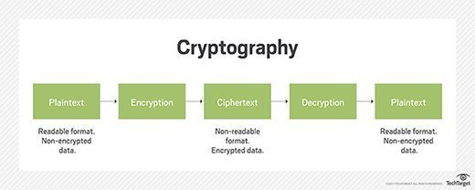

**Fig 2.1 Abstract view of Cryptography Architecture**

At the core of cybersecurity lies the need to protect sensitive information from unauthorized access and malicious intent. Cryptography, the science of encoding and decoding   
information, acts as a shield against prying eyes, ensuring that confidential data remains secure. Through the use of algorithms and mathematical principles, cryptography transforms plaintext into ciphertext, rendering it indecipherable to those without the proper keys.

One of the primary applications of cryptography in cybersecurity is in the establishment of secure communication channels. As information travels across networks, there is a constant risk of interception by malicious actors. Cryptographic protocols, such as SSL/TLS, encrypt data during transmission, safeguarding it from eavesdroppers and potential tampering. This ensures the confidentiality of sensitive information, such as login credentials and financial transactions, fostering trust in online interactions.

In the realm of authentication, cryptography plays a crucial role in verifying the identity of users and entities. Digital signatures, a cryptographic technique, provide a means of ensuring the integrity and authenticity of digital messages or documents. By using public and private key pairs, digital signatures not only verify the origin of a message but also confirm that it has not been altered during transmission.

Cryptography is instrumental in the implementation of secure storage mechanisms. Through techniques like encryption, sensitive data stored on devices or in the cloud remains protected even if unauthorized access occurs. This adds an additional layer of defense against data breaches and unauthorized disclosure, aligning with the overarching goal of cybersecurity.

**2.2 Elliptic Curve Cryptography**

In the intricate landscape of cybersecurity, Elliptic Curve Cryptography (ECC) stands out as an elegant and powerful cryptographic technique, leveraging the mathematical properties of elliptic curves to provide a foundation for secure communication and data protection. As digital threats evolve, ECC has emerged as a cornerstone in modern cryptographic systems, offering efficiency and robust security. This exploration delves into   
  
the intricacies of Elliptic Curve Cryptography and its pivotal role in enhancing cybersecurity. At its core, Elliptic Curve Cryptography is based on the mathematical properties of elliptic curves over finite fields. Unlike traditional public-key cryptosystems, ECC offers comparable security with significantly shorter key lengths, making it

computationally more efficient. This efficiency is particularly valuable in resource-constrained environments, such as mobile devices and Internet of Things (IoT) devices, where computational resources are limited.

One of the key strengths of ECC lies in its ability to provide the same level of security as traditional methods, such as RSA, with significantly smaller key sizes. The efficiency gains become especially evident in scenarios where bandwidth and computational resources are at a premium. This makes ECC particularly well-suited for applications where optimizing performance without compromising security is crucial. In the realm of secure communication, ECC is widely employed in key exchange protocols.

The Diffie-Hellman Ephemeral (DHE) and Elliptic Curve Diffie-Hellman (ECDHE) key exchange protocols, based on ECC, enable two parties to establish a shared secret over an untrusted network. The efficiency of ECC key exchange is particularly advantageous for securing communications in real-time, such as in secure web connections (HTTPS).

Digital signatures are another area where ECC shines. ECC-based digital signatures, such as ECDSA (Elliptic Curve Digital Signature Algorithm), provide a means of verifying the authenticity and integrity of digital messages. ECDSA offers comparable security to traditional digital signature algorithms but with shorter key lengths, reducing computational overhead. The inherent properties of elliptic curves contribute to the security of ECC. The elliptic curve discrete logarithm problem, upon which ECC is built, is considered computationally infeasible to solve efficiently. This mathematical foundation forms the basis for the security of ECC and has withstood extensive cryptanalysis, further solidifying its standing as a robust cryptographic method.

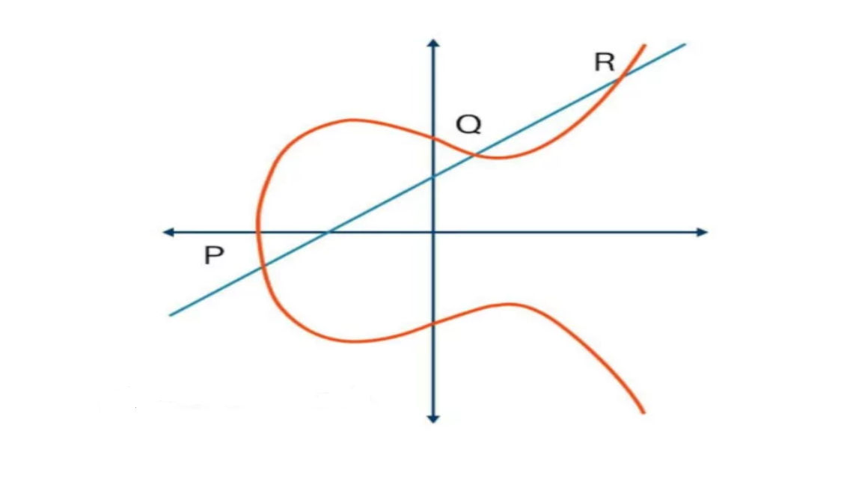

**Fig 2.2 A Basic Elliptic Curve**

As our digital landscape continues to evolve, and the demand for secure and efficient cryptographic solutions grows, Elliptic Curve Cryptography remains at the forefront. Its ability to provide strong security with smaller key sizes, making it well-suited for resource-constrained environments, underscores its importance in the ongoing efforts to fortify our digital systems against ever-evolving cyber threats.

In essence, the mathematical elegance of Elliptic Curve Cryptography continues to shape the landscape of cybersecurity, offering a sophisticated and efficient means of securing our digital interactions.

**2.3 Diffie Hellman Key Exchange**

The Diffie-Hellman Key Exchange is a cryptographic protocol that allows two parties to securely exchange cryptographic keys over an insecure channel. It was developed by Whitfield Diffie and Martin Hellman in 1976 and is one of the first public-key protocols. The protocol enables users to securely exchange secret keys even if an opponent is monitoring that communication channel. It works by allowing two parties (Alice and Bob) to agree on a shared secret key without any other party being able to intercept the key or learn anything about it.

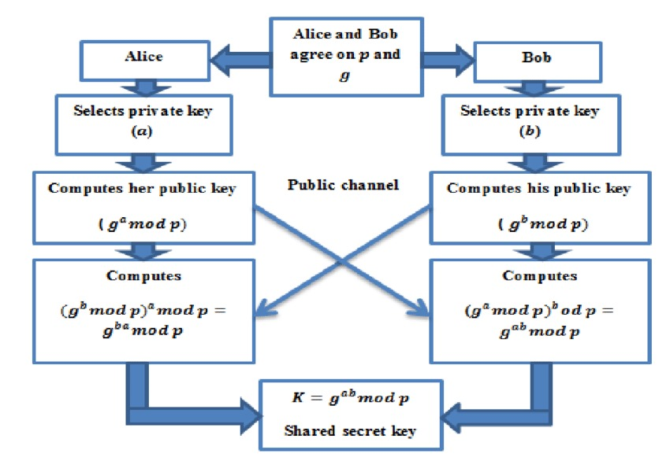

**Fig 2.3 Diffie Hellman Working Architecture**

The exchanged keys are used later for encrypted communication (e.g. using a symmetric cipher like AES). The Diffie-Hellman key exchange was the first widely used method of safely developing and exchanging keys over an insecure channel. It is still frequently implemented in a range of today’s different security protocols.

The Diffie-Hellman key exchange is complex and it can be difficult to get your head around how it works. It uses very large numbers and a lot of math, something that many of us still dread from those long and boring high school lessons.

**2.4 Introduction to the FourQ Curve**

FourQ is an elliptic curve developed by Microsoft Research that is designed for key agreement schemes (elliptic-curve Diffie–Hellman) and digital signatures (Schnorr) ¹.   
  
It offers about 128 bits of security and is equipped with a reference implementation made by the authors of the original paper. The curve is defined over a two-dimensional extension of the prime field defined by the Mersenne prime.

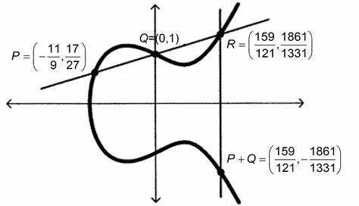

**Fig 2.4 FourQ Curve and Points Generated in the Field**

FourQ is a new, high-security, high-performance elliptic curve that targets the 128-bit security level ³. It is defined by the twisted Edwards equation: E (GF (p2)): – x2 + y2 = 1 + dx2y2, where p is the Mersenne prime p = 2^127 – 1 and d is a non-square in GF (p2).

FourQ is equipped with two nontrivial endomorphisms: related to the -power Frobenius map, and a low degree efficiently computable endomorphism (see complex multiplication). The curve is primarily used to generate pseudo-random numbers, digital signatures, and other data. The FourQ curve supports fast and secure scalar multiplication, which is the main operation in elliptic curve cryptography. The FourQ curve also has other desirable properties, such as resistance to side-channel attacks, twist security, and compatibility with existing standards.

**2.5 Quantum Computing**

Quantum computing is a revolutionary paradigm that leverages the principles of quantum mechanics to perform computations at speeds unattainable by classical computers. Unlike classical bits, which exist in states of either 0 or 1, quantum bits or qubits can exist in multiple states simultaneously, thanks to superposition. This inherent parallelism allows quantum computers to explore vast solution spaces exponentially faster than classical counterparts.

One significant implication of quantum computing is its potential to break widely-used cryptographic algorithms, such as those based on elliptic curve cryptography (ECC). ECC relies on the difficulty of solving mathematical problems related to elliptic curves for its security. Quantum computers, employing algorithms like Shor's algorithm, can efficiently factor large numbers, posing a threat to the security of ECC. The ability to factor large numbers quickly undermines the foundation of ECC-based encryption, as it relies on the difficulty of factoring large semiprime numbers for its security. As quantum computing matures, the field of cryptography faces the challenge of developing quantum-resistant algorithms to ensure the continued security of sensitive information in the era of quantum computation.

**2.6 Elliptic Curve Cryptography: Application, challenges, recent advances, and future trends: A comprehensive survey**

Elliptic Cryptographic techniques have evolved significantly, with Elliptic Curve (EC) Cryptography emerging as a leading method for securing open communication networks in the Modern Digital Era (MDE). This essay explores the significance of EC in enhancing security in various digital environments, such as social media, cloud computing, and the Internet of Things (IoT).

In the MDE, users rely heavily on technologies that require secure communication, such as social media platforms, cloud services, and IoT devices. The use of EC in these environments is crucial for preserving security and privacy. Cryptography plays a pivotal role in ensuring secure data transmission and information transfer over unsecure networks, protecting against data theft and attacks.

Cryptography, the art of encrypting documents and communications, uses keys to ensure that only intended recipients can decode and process the information. EC is particularly effective in this regard, offering robust encryption methods that are essential for securing digital communications. EC also plays a vital role in digital signatures, cryptographic data integrity, and authentication, ensuring that messages are delivered securely and only to the intended recipients.

Comparing EC to other cryptographic methods like RSA and Diffie–Hellman, ECDSA (Elliptic Curve Digital Signature Algorithm) stands out for its efficiency and security. EC-based schemes are more secure and suitable for use in cloud computing, e-health, and e-voting, providing significant benefits over traditional schemes.

The adoption of EC methods in distributed computing and asynchronous networking offers significant advantages. EC-based schemes enhance security in distributed computing and interdependent networking, providing a robust framework for secure interactions.

This comprehensive study of EC delves into scientific concepts, state-of-the-art methodologies, and innovative implementations. It serves as a valuable resource for academics and researchers interested in further analysis and development of EC-based schemes.

In conclusion, the adoption of EC in cryptographic methods is instrumental in upholding the integrity and authenticity of digital communications. By providing insights into the theoretical and practical aspects of EC, this research paper serves as a guide for implementing secure cryptographic techniques in digital environments. However, it is important to note that current cryptosystems are still vulnerable to attacks, highlighting the ongoing need for advancements in cryptographic methods to ensure secure digital interactions.

**2.7 Fast and Area Efficient Implementation of RSA Algorithm**

Efficient hardware implementations of public-key cryptosystems, particularly the Rivest-Shamir-Adleman (RSA) cryptosystem, have garnered significant interest in recent decades. This paper presents a high-frequency, low-latency implementation of RSA, achieved through a re-constructed shift-add multiplier and a binary digit-based modular exponentiation circuitry. The proposed implementation utilizes a binary bit distribution technique, where the most significant bit (MSB) is discarded to increase the operating frequency. The functionality of the algorithms is validated and compared using Hardware Description Language (HDL), Modelsim simulation, and Xilinx ISE 14.2 platform synthesis. The proposed RSA hardware implementation achieves a maximum operation frequency of 545 MHz and 298 MHz for bit sizes of 8 and 64, respectively. The method also shows improvements in speed and reduces the number of Look-up-tables (LUTs). Additionally, an application-specific integrated circuit (ASIC) implementation of the RSA cryptosystem is carried out using Cadence® Encounter® RTL Compiler v11.10-p005_1.[2]

The literature survey highlights advancements in RSA performance achieved through improved calculation methodologies and specialized hardware for multiplication. The review indicates potential improvements through subtle modifications. The use of   
  
  
dedicated shift-add multiplier hardware enhances scalar multiplication speed, benefiting RSA and Diffie-Hellman cryptographic techniques.

In the context of FourQ, similar performance enhancements can be realized without the need for dedicated hardware. Leveraging the FourQ approach can lead to comparable improvements in speed and efficiency, aligning with advancements observed in the paper. This approach focuses on harnessing the inherent capabilities of FourQ, streamlining the implementation process and minimizing dependencies on specialized hardware.

Incorporating specialized hardware in every implementation scenario is impractical. Therefore, exploring alternative approaches, such as FourQ, offers efficiency gains while maintaining versatility and adaptability in cryptographic processes. This approach contributes to a more diverse and optimized cryptographic landscape, offering promising avenues for future research and implementation.[2]

**2.8 Efficient group Diffie–Hellman key agreement protocols**

In the realm of cryptographic techniques, the Group Diffie–Hellman (GDH) key agreement protocol has emerged as a pivotal method for enabling secure communication among multiple participants. This protocol allows all group members to collaboratively establish a shared key, often by organizing them in a logical ring or binary tree and facilitating the exchange of Diffie–Hellman public keys among participants. This approach ensures that each member can contribute to and benefit from the shared key, enhancing the security and efficiency of the communication channel.

The GDH protocol's collaborative nature aligns with the broader goal of ensuring secure communication channels for multiple participants. By organizing group members in a logical ring or binary tree, the protocol optimizes the exchange of Diffie–Hellman public keys, streamlining the process of establishing a shared key. This not only enhances the security of the communication channel but also improves the efficiency of key agreement among group members.

Moreover, the GDH protocol opens up new possibilities for implementing cryptographic techniques using FourQ. By shedding light on the collaborative nature of the GDH protocol, the literature survey underscores the potential benefits of deploying FourQ in enhancing secure communication among diverse parties. This exploration not only provides insights into the GDH protocol but also offers a fresh perspective on optimizing secure communication channels through innovative cryptographic approaches.

However, it is important to acknowledge the challenges associated with implementing the GDH protocol. For instance, the protocol is susceptible to unknown key-share attacks, where an entity may mistakenly believe they share a key with one entity while another entity believes the key is shared with them. Similarly, key compromise impersonation attacks are possible if an entity's long-term private key is compromised, allowing the adversary to impersonate the entity.

Despite these challenges, the GDH protocol offers a robust and efficient approach to establishing group keys. By leveraging the secret sharing scheme and incorporating one-way key confirmation and digital certificates, the protocol ensures the confidentiality, integrity, and authenticity of group key establishment. Overall, the GDH protocol represents a significant advancement in cryptographic techniques, offering a secure and efficient method for enabling secure communication among multiple participants.

**2.9 An improved random bit-stuffing technique with a modified RSA algorithm for resisting attacks in information security (RBMRSA).**

In the realm of network applications and the internet, data and network security have become paramount in ensuring the integrity and confidentiality of communication systems. Cryptography stands out as a powerful tool for achieving these security goals. One of the key aspects of cryptography is the randomization of encrypted data, which not only enhances security but also increases the computational complexity of cryptographic algorithms.

This research study focuses on enhancing the security of the well-known RSA encryption algorithm (1024 key length) by incorporating an enhanced bit insertion algorithm. The aim is to address the vulnerabilities that have emerged in classical RSA due to advancements in computing technology and hacking systems. The proposed encryption algorithms aim to provide confidentiality and integrity by improving the diffusion degree without increasing the key length, thus enhancing the security of RSA against various attacks.

The security analysis of the study compared the proposed algorithm, referred to as RBMRSA, with classical RSA of 1024 key length using mathematical evaluation proofs. The experimental results were evaluated based on the avalanche effect and computational complexity. The results demonstrate that RBMRSA is superior to classical RSA in terms of security, although at the cost of increased execution time.

The research paper delves into the vulnerabilities of classical RSA, which relies on the difficulty of factoring large semiprime numbers for security. However, with the advent of quantum computing and side-channel attacks, classical RSA has shown vulnerabilities. To counter these challenges, the paper proposes the use of enhanced bit insertion techniques within a modified RSA framework (RBMRSA), which incorporates three prime numbers (p, q, and r) without increasing the key length. This modification aims to bolster RSA's security against common vulnerabilities while minimizing the impact on computational efficiency.

Despite its advantages, RBMRSA has some disadvantages. It can be expensive to implement, and RSA is still prone to common attacks such as exhaustive search, timing attacks, and common modulus attacks. Additionally, there are gaps in existing studies that need to be addressed to further enhance the security of RSA-based cryptographic systems.

In conclusion, the research paper offers a pragmatic solution to strengthen the security of RSA against emerging threats. By introducing enhanced bit insertion techniques within a modified RSA framework, RBMRSA offers a promising avenue for enhancing the cryptographic resilience of RSA in real-world applications. This research contributes to both theoretical advancements and practical enhancements in secure communication systems.

**2.10 FourQ on embedded devices with strong countermeasures against side-channel attacks**.

In the ever-expanding landscape of cybersecurity, the demand for energy-efficient, high-speed, and high-security cryptographic implementations on embedded devices has never been greater. Addressing this need, recent research has focused on optimizing the performance of elliptic curve cryptography (ECC) on embedded platforms using the FourQ elliptic curve.

The abstract of the research paper sets the stage by highlighting the key objectives of the study: to achieve energy efficiency, high-speed operations, and robust security in ECC implementations for embedded devices. The paper claims to set new speed records for constant-time curve-based scalar multiplication, Diffie-Hellman (DH) key exchange, and digital signatures at the 128-bit security level. Notably, the implementations target microcontrollers with varying bit lengths, catering to the diverse range of embedded devices in the market.

One of the primary insights gleaned from the research paper is its focus on optimizing energy efficiency without compromising on speed and security. This is particularly crucial for embedded devices, which often operate under stringent power constraints. By leveraging the FourQ elliptic curve, renowned for its compact arithmetic, the study strikes a delicate balance between computational performance and resource constraints. Tailored strategies for scalar multiplication, ECDH key exchange, and digital signatures are employed to maximize efficiency while maintaining robust security measures.

Moreover, the inclusion of elliptic curve Diffie-Hellman (ECDH) key exchange and digital signatures further enhances the paper's relevance. These cryptographic primitives are indispensable for secure communication and authentication, especially in resource-constrained environments. The proposed implementations not only demonstrate advancements in cryptographic techniques for embedded devices but also underscore the adaptability and practicality of the chosen FourQ elliptic curve.

However, despite the promising results, the research acknowledges a significant limitation: the FourQ curve is still in its nascent stages and requires further research and development to harness its full security potential. Specifically, more work is needed to integrate the curve into modern cryptographic areas like ECDH and digital signatures, ensuring robust protection against emerging threats.

In conclusion, the research paper represents a significant step forward in the realm of energy-efficient cryptography for embedded devices. By optimizing performance while mitigating security risks, the study paves the way for the widespread adoption of ECC in resource-constrained environments. Moving forward, continued research and innovation will be crucial to fully unlock the potential of the FourQ curve and usher in a new era of secure communication on embedded platforms.

**2.11 FourQ NEON: Faster Elliptic Curve Scalar Multiplications on ARM Processors.**

The paper presents a groundbreaking implementation of the elliptic curve FourQ for 32-bit ARM processors with NEON support, aiming to achieve high-speed and high-security cryptographic operations. Leveraging the compact arithmetic of the FourQ curve, the researchers design a vectorized implementation that delivers exceptional performance across a wide range of ARM platforms. Notably, the software is fortified against timing and cache attacks, ensuring robust security measures.

The key highlight of the research lies in its ability to achieve remarkable speedups compared to other curve-based alternatives. For instance, a single variable-base scalar multiplication operation is computed in approximately 235,000 Cortex-A8 cycles or 132,000 Cortex-A15 cycles. These results translate into speedups ranging from 1.3x to 1.7x compared to the fastest genus 2 Kummer and Curve25519 implementations on the same platforms. Moreover, when compared to the NIST standard curve K-283, the speedups surpass 4x and 5.5x, respectively, showcasing the superior performance of the FourQ curve.

The manuscript introduces a novel approach to enhancing the computational efficiency and security of elliptic curve cryptography, particularly focusing on the FourQ curve. By targeting 32-bit ARM processors with NEON support, the research addresses a critical need in the industry for high-performance cryptographic solutions for widely used architectures. The vectorized implementation, a key aspect of the study, demonstrates a significant performance boost across various ARM platforms, underscoring the importance of leveraging parallel processing capabilities for optimal performance.

Furthermore, the adaptability and versatility of the proposed solution are highlighted, ensuring its relevance and applicability across a broad range of ARM platforms. This adaptability, coupled with the incorporation of NEON support and tailored design for ARM architecture intricacies, enables the researchers to achieve high-speed cryptographic operations without compromising on security.

However, the research also acknowledges a limitation: the FourQ curve is still in its early stages and requires further research to fully harness its security potential in modern cryptographic applications such as ECDH and digital signatures. Despite this limitation, the research represents a significant advancement in high-speed, high-security cryptography for ARM processors, laying the foundation for future developments in this field.

**2.12 Quantum cryptography: Public key distribution and coin tossing.**

The abstract introduces the concept of using elementary quantum systems, like polarized photons, to transmit digital information, leading to novel cryptographic phenomena impossible with traditional methods. A quantum channel can be used alongside insecure classical channels to distribute random key information between users, ensuring its secrecy. Additionally, a protocol for coin-tossing through quantum messages is presented, offering security against traditional cheating methods but vulnerable to the Einstein-Podolsky-Rosen paradox.

The integration of quantum cryptography with elliptic curve cryptography (ECC) offers significant advantages. ECC provides a secure foundation for key exchange, digital signatures, and encryption. When combined with quantum cryptography, ECC can leverage the inherent security of quantum protocols.

One key advantage is in key exchange. The shared secret key obtained through Quantum Key Distribution (QKD) can serve as a symmetric key for elliptic curve-based encryption algorithms, ensuring a secure key exchange process. Additionally, random bits generated through quantum coin tossing can be used as parameters for generating digital signatures using elliptic curve-based algorithms, enhancing the overall security of the cryptographic system.

The integration of quantum and elliptic curve cryptography presents a robust and secure framework for various cryptographic applications, especially in the quantum era where threats from quantum computers to classical cryptographic algorithms are a growing concern. This combined approach leverages the strengths of both quantum and elliptic curve cryptography, offering enhanced security and resilience against attacks.

However, these cryptosystems are not without their vulnerabilities. They are susceptible to various attacks, including Distributed Denial of Service (DDoS) and Man-in-the-Middle (MitM) assaults. As such, ongoing research and development are essential to address these vulnerabilities and further enhance the security of quantum and elliptic curve cryptography systems.

In conclusion, the integration of quantum cryptography with elliptic curve cryptography represents a significant advancement in cryptographic techniques, offering enhanced security and resilience against attacks in the quantum era. Continued research and development in this field will be crucial to further strengthen these systems and mitigate existing vulnerabilities.

**2.13 Using quantum key distribution for cryptographic purposes: A survey**

The insights provided shed light on the integration of Quantum Key Distribution (QKD) with Elliptic Curve Cryptography (ECC) and its implications for key distribution, authentication, post-processing, and the development of quantum-safe ECC.

Key distribution is a critical aspect of cryptography, and QKD offers a unique solution by providing a shared key that can be used as a symmetric key for ECC-based encryption algorithms. ECC is known for its efficiency and security in key exchange, and the combination of QKD and ECC enhances the overall security of communication by ensuring that the shared key remains secret.

Authentication is another key aspect of secure communication, and the integration of QKD with ECC enables mutual authentication between parties. The shared key obtained through QKD can be used to generate digital signatures using elliptic curve algorithms, thus ensuring the authenticity of the communicating entities.

Post-processing of the raw key generated by QKD is essential to ensure its security and reliability for use in ECC. Techniques such as error correction and privacy amplification may be applied to the raw key to enhance its security before being used in ECC.

As a long-term strategy, researchers are exploring the development of quantum-resistant or quantum-safe ECC. This involves designing ECC algorithms that are secure against attacks by quantum computers, which could potentially break traditional ECC. This development is crucial in ensuring the long-term security of ECC in the face of advancing quantum computing technology.

However, it is important to note that the integration of QKD with ECC is not without its challenges. If QKD is not properly coded, hackers could exploit loopholes in the code to gain access to keys and confidential data. Therefore, it is essential to rigorously test and validate QKD implementations to ensure their security and protect against passive and active side-channel attacks.

In conclusion, the integration of QKD with ECC offers significant advancements in key distribution, authentication, and security in communication. While there are challenges to be addressed, such as ensuring the security of QKD implementations, the integration of QKD with ECC holds great promise for enhancing the security of communication in the quantum era. Continued research and development in this area will be crucial to realizing the full potential of this integration and ensuring the security of communication systems in the future.

**Chapter 3**

**SYSTEM DESIGN**

**3.1 System Architecture**

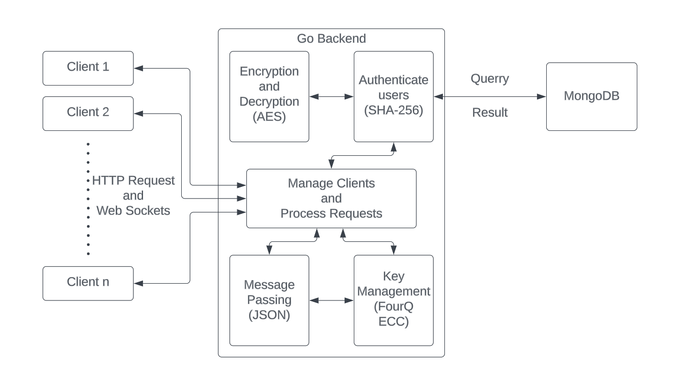

**Fig 3.1.1 System Architecture of Chat Application**

The system architecture for our secure chat application embodies a meticulous fusion of cutting-edge technologies and strategic design principles aimed at delivering unparalleled security, functionality, and user experience. At its core lies a robust authentication mechanism that ensures the integrity and confidentiality of user credentials from end to end.

User authentication initiates with AES encryption, safeguarding user credentials during transmission to the backend server. Once received, these encrypted credentials are decrypted, enabling seamless processing while maintaining data confidentiality.   
  
Leveraging MongoDB as our database solution, the decrypted password undergoes SHA 256 hashing, generating an irreversible representation that is compared with the stored hash, validating user authenticity.

This authentication process serves as the gateway to a seamlessly connected user experience. The backend, powered by Go and orchestrated through Gin, ensures scalable, high-performance server-side components, while React frontend components offer intuitive interfaces and responsive design. Integration of CORS facilitates secure cross-origin communication, ensuring accessibility across diverse environments without compromising security.

With user authentication secured, connectivity is facilitated through WebSockets, enabling real-time, bidirectional communication between clients and servers. This dynamic communication infrastructure empowers users to engage in responsive conversations without the need for frequent refreshing or polling, enhancing the overall user experience.

Underpinning this architecture is a comprehensive security framework that leverages advanced cryptographic techniques. FourQ ECC, employed for key generation via Diffie-Hellman protocol, enhances communication security, while AES encryption fortifies message confidentiality. Concurrently, SHA 256 hashing of user credentials bolsters authentication mechanisms, mitigating the risk of unauthorized access.

Through meticulous attention to detail, rigorous testing, and ongoing optimization, we aim to set a new standard for secure communication platforms, empowering users to communicate confidently in an ever-evolving digital landscape.

**3.2 UML Diagrams**

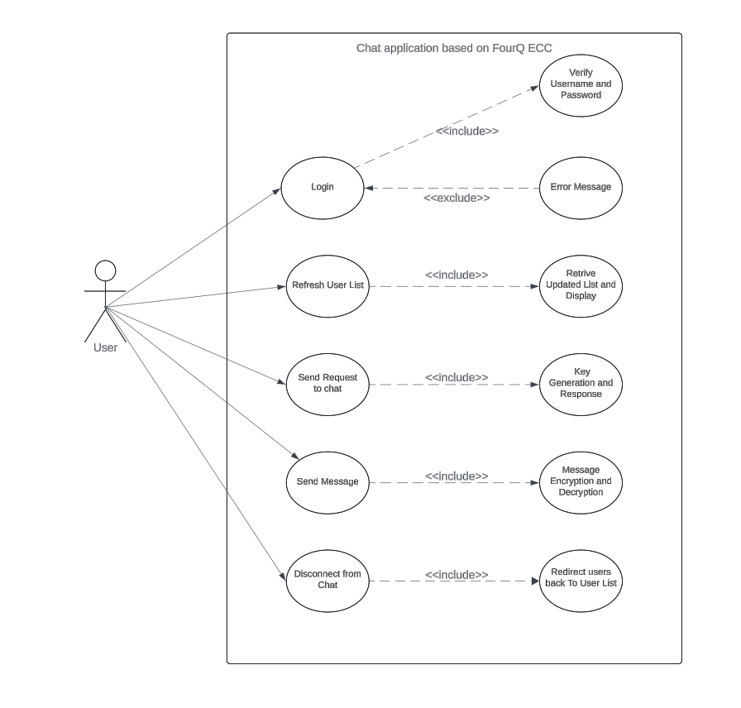

**Figure 3.2.1 Use case diagram**

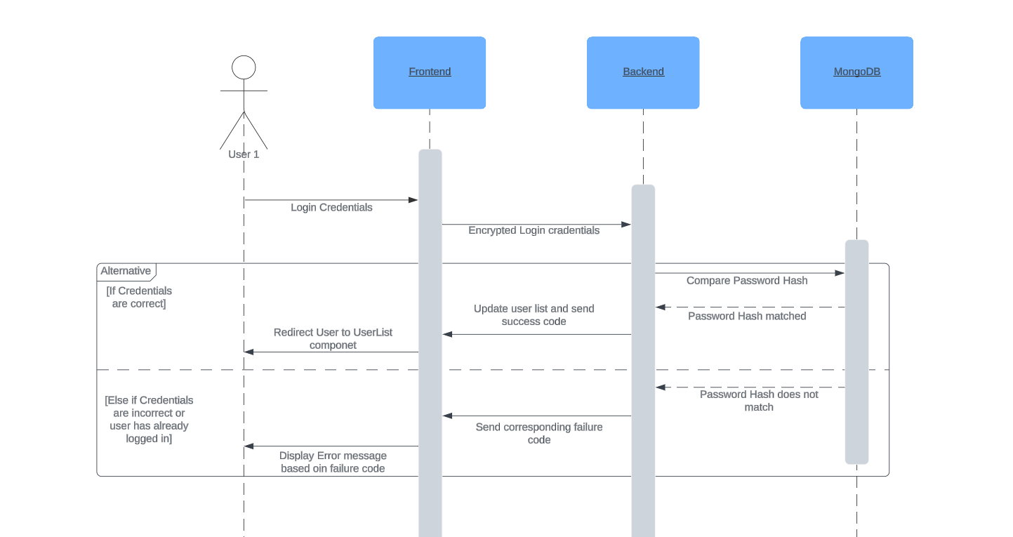

**Fig 3.2.2: Sequence Diagram for Authentication**

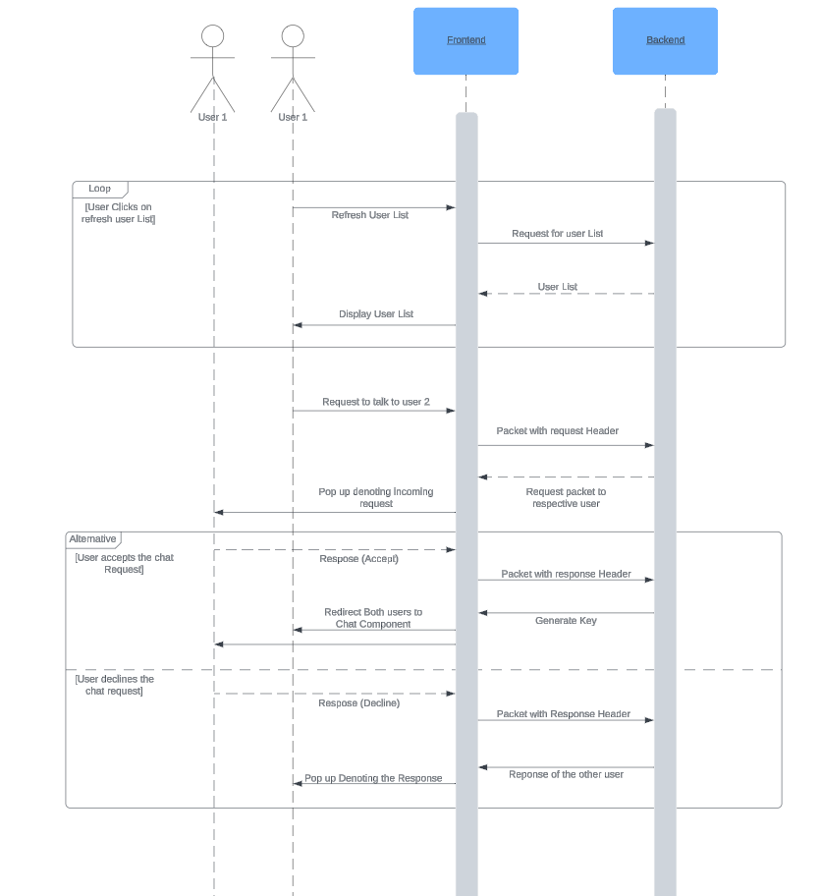

**Figure 3.2.3 Use case diagram for sending and accepting request**

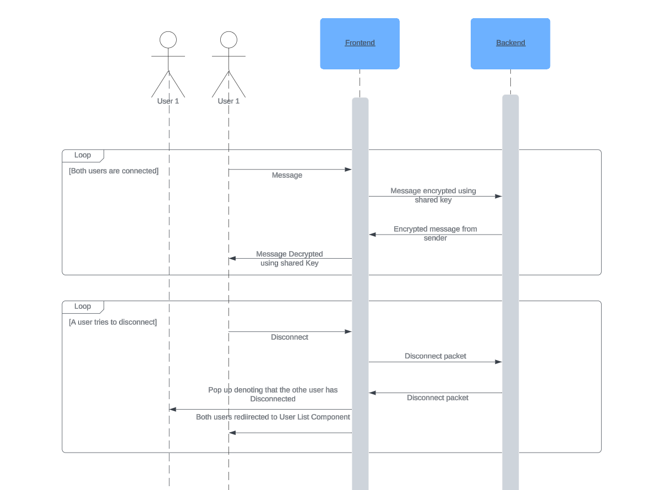

**Figure 3.2.4 Sequence diagram for sending messages**

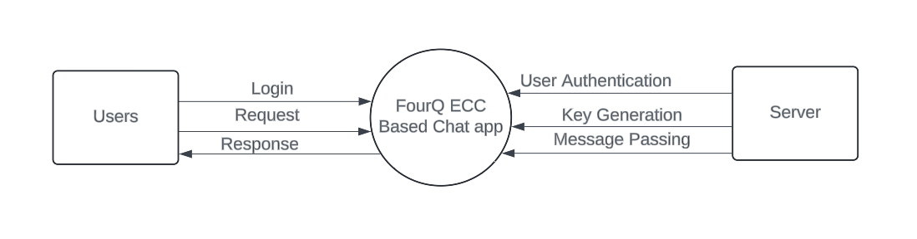

**Figure 3.2.5 DFD Level 0**

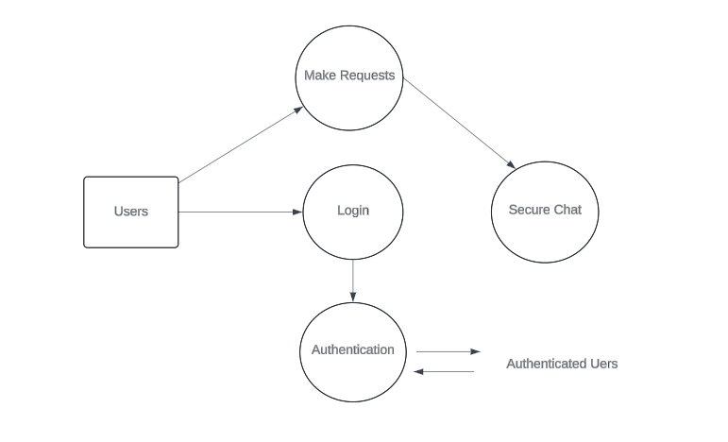

**Figure 3.2.6 DFD Level 1**

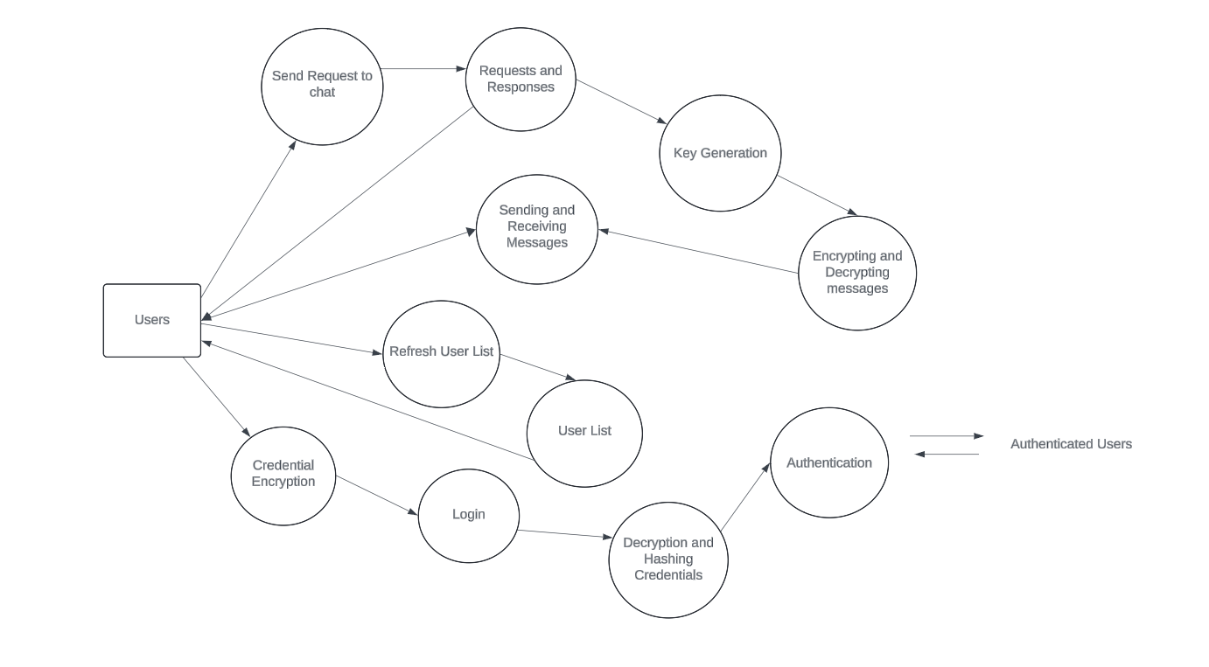

**Figure 3.2.7 DFD Level 2**

**Chapter 4**

**SOFTWARE REQUIREMENTS SPECIFICATION**

* 1. **Functional Requirements**
* **Enhancing computational efficiency**: Reduce computation costs compared to traditional cryptographic systems, thereby improving overall efficiency in cryptographic operations.
* **Providing quantum-resistant security**: Withstand attacks from emerging quantum computing technologies, ensuring the security of sensitive data in the face of evolving threats.
* **Addressing vulnerabilities in existing cryptographic systems:** Seeks to mitigate weaknesses present in conventional cryptographic algorithms, such as RSA and ECC, which are susceptible to quantum threats.
* **Promoting adoption of Elliptic Curve Cryptography (ECC)**: FourQ serves as a catalyst for the wider adoption of ECC as a quantum-resistant cryptographic solution, fostering a more secure cryptographic infrastructure.
* **Facilitating real-world cryptographic applications**: The efficiency and security offered by FourQ make it suitable for a wide range of cryptographic applications, enabling organizations to implement robust security measures in their digital systems and communications.
* **Positioning organizations for long-term security**: By embracing FourQ, organizations can proactively fortify their cryptographic systems against future   
    
    
  threats, ensuring the long-term security and resilience of sensitive data in an increasingly interconnected digital environment.
  1. **Methodology**
* **Authentication**

Our approach begins with ensuring that the people who access secure chat application are genuine. This is done using Advanced Encryption Standard (AES) in conjunction with SHA-256 hashing algorithm. In this case, AES is used to encrypt credentials such as passwords and usernames of users so that they can be securely transmitted via a network.SHA-256 then hashes these credentials generating fixed size output which can be used to uniquely identify a user. This hash would be compared with the hash stored in the database, which contains hashes of authorized users. Using this combination of cryptographic techniques, we create a reliable and secure process for verifying the identities of users before allowing them into the chat application. The authentication flow is show in Figure.

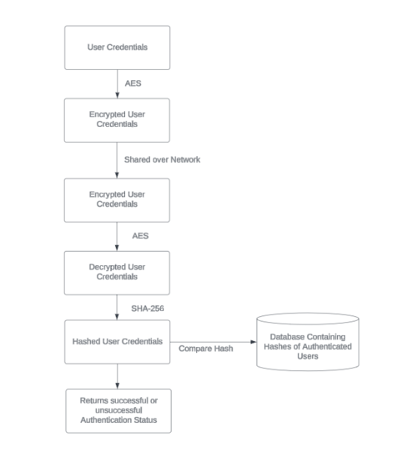

**Fig 4.2.1: Authentication Process**

* **Generating Shared Keys**

As soon as authentication is completed and clients are ready to chat with others who are online, we will begin with shared key generation using Diffie-Hellman with FourQ ECC. The second phase of our approach involves generating shared keys for secure communication between users. We utilize Diffie-Hellman key exchange algorithm to generate a shared secret key which enable two parties to communicate secretly even on an insecure channel. Our implementation employs elliptic curve cryptography (ECC) library FourQ which generates public and private keys that are needed for Diffie-Hellman algorithm. This method guarantees that the shared keys can be created efficiently and maintained secure against any eavesdropping or interception attempts. Through combining FourQ ECC with Diffie-Hellman, we create a strong framework to securely send messages within the chat application.

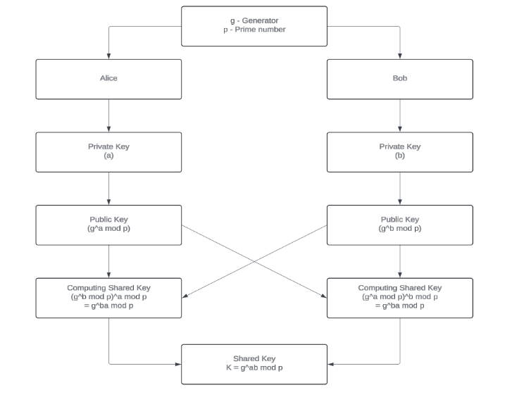

**Fig 4.2.3: Generating Keys Using Diffie Hellman**

* **Encrypting and Decrypting Messages using Shared Key**

Subsequent to the authentication phase, wherein users are verified and granted access, the communication process advances to the encryption and decryption stage. In this phase of secure message exchange between authenticated users, unique shared keys serve as a basis for it. Before sending, messages are encrypted by employing the strong AES-256 encryption algorithm. The recipient’s designated shared key is used in this encryption process thereby ensuring that messages remain private and resistant to unauthorized access through network during transmission. Using their corresponding shared keys, on receiving; the receiver can decrypt a message back into its original form for understanding purposes. This iterative process of encryption and decryption using shared keys enhances confidentiality and integrity of all conversations within chat sessions thus meeting tight security requirements for protection sensitive data.

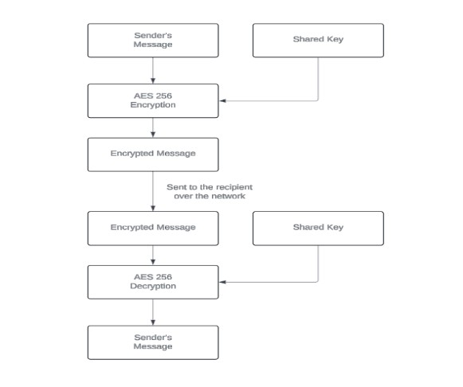

**Fig 4.2.4 Encrypting and Decrypting Messages Using Shared Key**

* 1. **Functional Components**

**4.3.1 Elliptic Curve Cryptography**

An elliptic curve is a fascinating mathematical object with diverse applications in fields like cryptography. It is often used as a “Trapdoor Function”.

Elliptic curve addition is defined as A * B=(-C), when all points belong to the same curve. There is a geometric interpretation of addition or doubling (abstracted as “ * ”). If we draw a straight line from A to B and find the intersection with curve we would get -C point, finding the opposite point over the x-axis would give us C.

Now if we draw a straight line from A to C, we get (-D) as: A * C = (-D). Again, reflect the point along X- Axis to get D.

We can now repeat the process for “ k ” no. of times. i.e. Dotting function k * P = P + P + ... + P (k times).

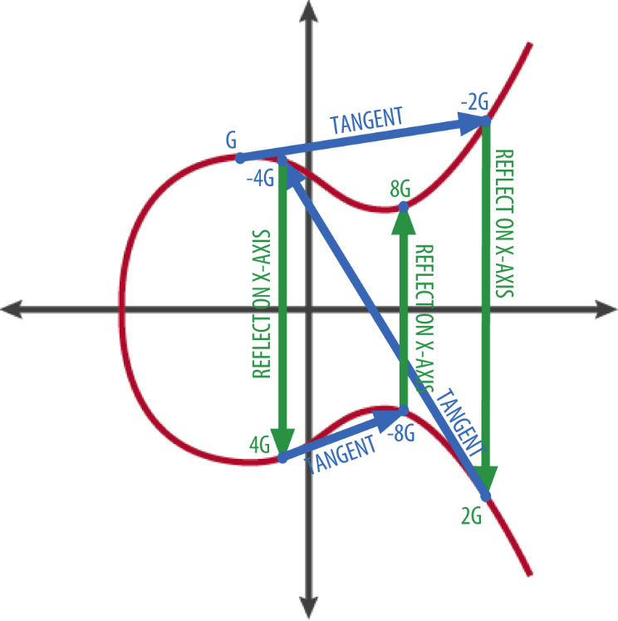

**Fig 4.3.1: FourQ Curve**

If we apply several operations one after another it could be depicted as the following:

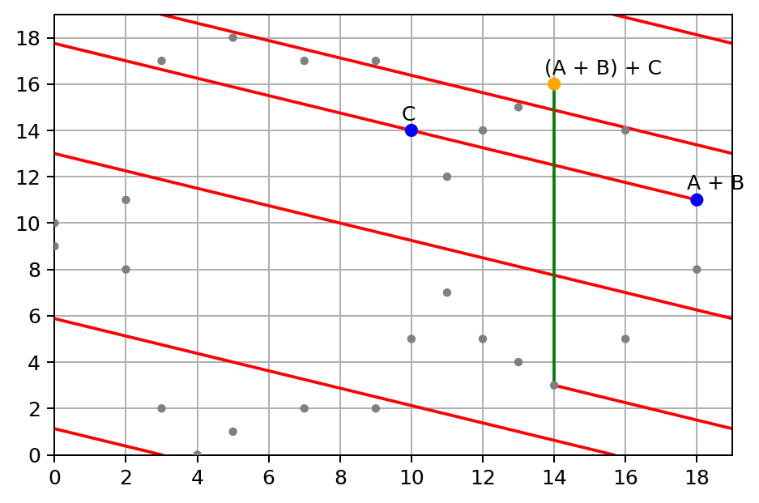

**Fig 4.3.2: FourQ Curve Finite Field**

A private key is a single number selected from the range [0, n-1] where n = 2256 . So the private key space is 22256, to give you an idea of how big it is 2256 ~ 1.158 * 1077.

For comparison, the visible universe is estimated to contain between 1078 and 1082 atoms. If you pick a number randomly from this space there is practically impossible to guess it.

**In a Public Key Cryptosystem:**

The public key could be derived from the private key using the following formula:

K = k * G

Where:

* **k** - private key
* **G** - generator point is defined as constant for every elliptical curve,
* **\*** - is the elliptical curve multiplication operator.

Because this operation is performed over finite field multiplication is not reversible, thus if you have a public key and generator point it is not possible to divide public key K value by generator point G value to derive k. Because multiplication is not reversible you can safely share the public key with the world.

**4.3.2 FourQ Curve**

FourQ, introduced by Costello and Longa in 2015 is defined by the complete twisted Edwards Equation defined over the Finite Field 2127 -1 ( Mersenne Prime ). FourQ targets a 128-bit security level. It provides efficient computation of scalar multiplications, crucial for cryptographic primitives like ECDH (Elliptic-Curve Diffie–Hellman). All group operations are performed in constant time to prevent timing and side channel attacks.

Introduced in 2015 by Craig Costello and Patrick Longa from Microsoft Research. The curve’s reference implementation, called FourQlib, is open source and runs on Windows, Linux and IoT platforms.

Key Agreement Schemes (Elliptic-Curve Diffie–Hellman): FourQ enables secure key exchange between parties. This is crucial for establishing shared secrets over an insecure channel. Digital Signatures (Schnorr): It provides a reliable mechanism for verifying the authenticity and integrity of messages or data.

In tests conducted by the Microsoft Research team, FourQ demonstrated impressive speed. It was four to five times faster than the NIST P-256 curve. It was two to three times faster than Curve25519 (which is used in protocols like Tor and Bitcoin).

The FourQ curve is an elliptic curve defined over a finite field, particularly suitable for cryptographic applications due to its efficiency and security properties. Let's delve into the details of the formula and the workings of the FourQ curve:

* **Mathematical Formulation**: The FourQ curve is defined over a finite field E(Fp) is a prime number. The equation defining the curve in projective coordinates is:

E:y2 =x3+b

Where:

- x, y are coordinates representing points on the curve.

- b is a parameter chosen to ensure the curve's properties, particularly its security against various cryptographic attacks.

- The curve equation is intentionally simplified compared to traditional elliptic curves, resulting in computational efficiency while maintaining security.

* **Representation:**

The FourQ curve can be represented using various coordinate systems, including affine, projective, and extended coordinates. Projective coordinates are commonly used in cryptographic computations due to their efficiency and resistance to certain types of attacks.

* **Group Structure**:

The FourQ curve forms an elliptic curve group E(Fp), which has a well-defined addition operation. Given two points P and Q on the curve, their sum P + Q is another point on the curve. The group also includes an identity element, denoted as O, which serves as the additive identity.

* **Efficient Arithmetic Operations:**

The FourQ curve supports efficient arithmetic operations, including point addition, point doubling, and scalar multiplication. These operations are fundamental to many cryptographic protocols, such as digital signatures and key exchange algorithms.

**Point Addition**: Given two distinct points P and Q , their sum P + Q is computed using geometric rules defined by the elliptic curve equation. Projective coordinates allow for efficient point addition operations with minimal overhead.

**Point Doubling**: Doubling a point P on the curve involves finding the tangent line to the curve at P and computing its intersection with the curve to obtain the doubled   
  
point 2P . This operation is crucial for scalar multiplication and other cryptographic computations.

**Scalar Multiplication**: Scalar multiplication involves repeatedly adding a point P to itself a specified number of times, determined by a scalar integer **k** . Efficient   
algorithms, such as double-and-add or Montgomery ladder, are employed to compute scalar multiplication efficiently.

* **Security Considerations:**

The FourQ curve is designed to provide strong security properties, including resistance against various cryptographic attacks:

**Discrete Logarithm Problem**: The security of the FourQ curve relies on the hardness of the discrete logarithm problem, which is believed to be computationally infeasible to solve efficiently for large prime fields.

**Quantum Resistance**: FourQ is specifically designed to resist attacks from quantum computers, including Shor's algorithm, which threatens the security of many traditional cryptographic schemes based on integer factorization and discrete logarithms.

Overall, the FourQ curve offers a balance between computational efficiency and security, making it a promising choice for a wide range of cryptographic applications in the modern digital landscape.

**4.3.3 AES ( Advanced Encryption Standard )**

Advanced Encryption Standard (AES) is a specification for the encryption of electronic data established by the U.S National Institute of Standards and Technology (NIST) in 2001.

AES is widely used today as it is a much stronger than DES and triple DES despite being harder to implement.

Points to remember

* AES is a block cipher.
* The key size can be 128/192/256 bits.
* Encrypts data in blocks of 128 bits each.

That means it takes 128 bits as input and outputs 128 bits of encrypted cipher text as output. AES relies on substitution-permutation network principle which means it is performed using a series of linked operations which involves replacing and shuffling of the input data.

How AES encryption works

AES includes three block ciphers or cryptographic keys:

* AES-128 uses a 128-bit key length to encrypt and decrypt message blocks.
* AES-192 uses a 192-bit key length to encrypt and decrypt message blocks.
* AES-256 uses a 256-bit key length to encrypt and decrypt message blocks.

Each cipher encrypts and decrypts data in blocks of 128 bits using cryptographic keys of 128, 192 and 256 bits, respectively. The 128-, 192- and 256-bit keys undergo 10, 12 and 14 rounds of encryption, respectively. A round consists of several processing steps including substitution, transposition and mixing of the plaintext input to transform it into the final ciphertext output. The more rounds there are, the harder it becomes to crack the encryption, and the safer the original information.

In AES, numerous transformations are performed on data. First, the data is put into an array, after which the cipher transformations are repeated over multiple encryption rounds. The first transformation is data substitution using a substitution table and a predefined cipher. In the second transformation, all data rows are shifted by one except the first row.

The third transformation mixes columns using the Hill cipher. The last transformation is performed on each column, or data block, using a different part or a small portion of the encryption key. Longer keys need more rounds to complete.

During decryption, the message recipient uses a copy of the cipher to remove the various layers of encryption and convert the ciphertext back into plaintext. Post-conversion, they can read the message, knowing that it was not intercepted or read by anyone else.

**4.3.4 Diffie-Hellman Key Exchange**

We use the Diffie-Hellman key exchange algorithm to enable two parties establish a common secret over an insecure channel. Our implementation employs elliptic curve cryptography (ECC) library FourQ which generates public and private keys that are needed for Diffie-Hellman algorithm. This method guarantees that the shared keys can be created efficiently and maintained secure against any eavesdropping or interception attempts.   
  
Through combining FourQ ECC with Diffie-Hellman, we create a strong framework to securely send messages within the chat application.

The Diffie-Hellman key exchange protocol is a fundamental cryptographic technique used to establish a shared secret key between two parties over an insecure communication channel. It allows these parties to agree on a secret key without ever explicitly transmitting it, thus providing a secure means for establishing a secure communication channel.

The below diagram depicts the flow of working of the Diffie Hellman Key Exchange Scheme. Alica and Bob are the two ends involved in a communication and exchange and share keys to authenticate themselves in a public cryptosystem.



**Fig 4.3.3 Diffie Hellman Key Exchange Scheme**

**4.4 SYSTEM REQUIREMENTS**

**4.4.1 Hardware Requirements**

The FourQ library is an implementation of the FourQ curve, a high-security elliptic curve designed for use in cryptographic protocols. The hardware requirements for using the FourQ library depend on various factors such as the desired level of performance, target platform (e.g., microcontroller, FPGA, CPU), and specific application requirements. Here are some general guidelines:

* **Processor:** 
  + For microcontrollers: A 32-bit or 64-bit processor with support for integer arithmetic operations and preferably hardware multiplication and division.
  + For general-purpose CPUs: Any modern processor with support for integer arithmetic operations and preferably support for vector instructions (e.g., SIMD instructions like SSE, AVX).
  + For FPGAs: A FPGA with sufficient resources (e.g., LUTs, DSP blocks) to implement the necessary arithmetic operations efficiently.
* **Memory**:
  + **RAM**: The library typically requires a few kilobytes of RAM for storing variables and temporary data during computation. The exact amount depends on the specific operations performed and the desired performance.
  + **ROM**: The code size of the library depends on the implementation and configuration. It typically ranges from tens to a few hundred kilobytes.
* **Network:** Stable internet connection with minimum bandwidth of 5 Mbps for real-time communication

**4.4.2 Software Requirements**

* **Operating System**: Consider the operating environment and constraints such as power consumption, operating temperature, and size constraints (especially for embedded systems).

- Windows 10 or later

- macOS 10.13 or later

- Linux (Ubuntu, CentOS, or similar)

* **Development Tools:**

- Go programming language for backend development

- React framework for frontend development

- Visual Studio Code or similar IDE for coding

- Git for version control

* **Database:** MongoDB for storing user data.

**Chapter 5**

**SOFTWARE TESTING**

**5.1 Unit Testing**

Unit testing is a fundamental practice in software development aimed at ensuring the reliability, functionality, and stability of software systems. By isolating and testing individual components or units of code, developers can identify and fix defects early in the development cycle, leading to more robust and maintainable software. Unit tests focus on verifying the correctness of specific functionalities or behaviors, typically through automated test cases that simulate various inputs and conditions. This systematic approach to testing helps detect bugs, regressions, and unexpected behavior, allowing developers to make timely corrections before they escalate into larger issues. Moreover, unit testing promotes code modularity, as well-written tests encourage the creation of cohesive and loosely coupled components. Ultimately, investing time in comprehensive unit testing leads to improved code quality, enhances developer confidence in making changes, and contributes to the overall reliability and success of software projects.

In a chat application leveraging the FourQ curve for Diffie-Hellman key exchange and AES for encryption, unit testing plays a pivotal role in ensuring the reliability and security of the communication protocol. Unit tests are essential to validate the functionality of individual components responsible for key generation, exchange, and encryption processes. Tests can verify that the implementation of the FourQ curve adheres to cryptographic standards, generating secure and valid elliptic curve parameters. Furthermore, unit tests can scrutinize the Diffie-Hellman key exchange mechanism, confirming that it produces shared secret keys correctly and securely. For AES encryption, unit tests are crucial in validating the encryption and decryption routines, ensuring that messages are encrypted with the correct keys and decrypted accurately on both ends of the communication channel.

Additionally, comprehensive unit tests can assess error handling and edge cases, fortifying the application against potential vulnerabilities and ensuring robustness in various scenarios. By employing rigorous unit testing practices, the chat application can instill confidence in its security mechanisms, bolstering trust among users in the confidentiality and integrity of their communications.

* **Unit Testing Test Cases:**

-**User Authentication**:

- Test case 1: Verify that a user can log in with valid credentials.

- Test case 2: Verify that a user cannot log in with invalid credentials.

* **Key Generation**:

- Test case 3: Verify that public and private keys are generated correctly.

* **Message Encryption**:

- Test case 4: Verify that messages are encrypted and decrypted correctly using ECC with the FourQ curve.

**5.2 Integration Testing:**

Integration testing is a crucial phase in software development where individual units or components are combined and tested as a group to ensure they work together seamlessly. Unlike unit testing, which focuses on testing isolated units of code, integration testing evaluates the interactions and integration points between these units. This type of testing verifies that different modules, services, or subsystems integrate correctly and perform as expected when combined, uncovering any issues that may arise from the integration process. Integration tests validate the flow of data, communication protocols, and interfaces between components, helping to identify compatibility issues, interface mismatches, or unexpected dependencies. By conducting integration testing, developers can detect and rectify integration errors early in the development lifecycle, reducing the risk of critical failures in complex software systems. Additionally, integration testing plays a vital role in ensuring the overall functionality, interoperability, and reliability of the software before deployment, thereby contributing to the delivery of high-quality and robust applications.

Integration testing in a chat application employing the FourQ curve for Diffie-Hellman key exchange and AES for encryption is crucial for verifying the seamless interaction between its various components and ensuring the overall security and reliability of the communication protocol. Integration tests focus on assessing how different modules and subsystems work together to achieve the desired functionality. In the context of this chat application, integration tests would validate the end-to-end encryption process, ensuring that messages are securely exchanged between users and that the cryptographic operations involving the FourQ curve and AES encryption are properly integrated and functioning as intended. These tests would simulate real-world scenarios, including multiple users exchanging messages concurrently, and verify that the encryption and decryption processes maintain data confidentiality and integrity throughout the communication flow. Additionally, integration tests would evaluate the compatibility of the chat application with different platforms and environments, ensuring consistent behaviour across various devices and network conditions. By conducting thorough integration testing, the chat application can identify and rectify any potential integration issues or vulnerabilities, thereby enhancing the overall security and performance of the system.

**5.3 Validation Testing:**

Validation testing is a critical phase in the software development lifecycle focused on verifying whether a software product meets the intended requirements and fulfills the needs of its users. Unlike verification testing, which ensures that the software conforms to its specifications, validation testing validates that the software satisfies the user's expectations and solves the intended problem effectively. This type of testing evaluates the software from the end user's perspective, validating its functionality, usability, performance, and overall fitness for purpose. Validation testing involves techniques such as acceptance testing, user acceptance testing (UAT), and beta testing, where the software is tested in real-world scenarios or by actual users to assess its alignment with user needs and business objectives. By performing validation testing, organizations can gain confidence that their software meets the desired outcomes, enhances user satisfaction, and delivers value to stakeholders.

Additionally, validation testing helps identify any discrepancies between the software and user expectations early in the development process, enabling timely adjustments and improvements to ensure the success of the software product.

Validation testing in a chat application employing the FourQ curve for Diffie-Hellman key exchange and AES for encryption is essential for ensuring that the implemented security measures effectively safeguard user communications and meet the specified requirements. Validation tests focus on verifying whether the application meets the intended objectives and user expectations. In the context of this chat application, validation testing would assess the efficacy of the encryption mechanisms in protecting the confidentiality and integrity of messages exchanged between users. It would validate that the Diffie-Hellman key exchange protocol successfully establishes shared secret keys securely, and that the AES encryption scheme effectively encrypts and decrypts messages using these keys. Additionally, validation tests would ensure that the user interface provides intuitive controls for initiating secure conversations and that users can easily verify the encryption status of their messages. By rigorously validating the security features and user experience of the chat application, validation testing instills confidence in its ability to provide secure and seamless communication for users while meeting their expectations and requirements.

**Chapter 6**

**CONCLUSION AND FUTURE ASPECTS**

In conclusion, the secure chat application utilizing FourQ elliptic curve cryptography represents a significant step towards ensuring private and secure communication in the digital age. By leveraging the robust security features of FourQ ECC, the application offers users a reliable means to encrypt their messages, ensuring confidentiality and integrity.

The use of AES encryption for message encryption, along with the Diffie-Hellman key exchange for secure key establishment, further enhances the security of the application. These measures, combined with a secure login mechanism and real-time communication through WebSocket, provide users with a comprehensive and secure messaging experience.

Looking ahead, there is immense potential to further enhance the application's security features and user experience. Integrating quantum computing could potentially improve both performance and security, offering even greater levels of protection for user data.

Overall, the secure chat application demonstrates the practical implementation of advanced cryptographic techniques to address the growing need for secure communication channels. As digital threats continue to evolve, it is imperative to stay abreast of the latest advancements in cryptography to ensure the security and privacy of digital communications.

**FUTURE ASPECTS:**

The future of the secure chat application utilizing FourQ elliptic curve cryptography is promising, with several avenues for enhancement and improvement. One key area for development is enhanced security features. As quantum computing advances, so too must our cryptographic algorithms. New security features may include post-quantum cryptography algorithms that can protect the chat app on IoT against emerging quantum attacks. This would ensure that the application remains secure and resilient in the face of evolving threats.

User experience improvements are also crucial for the application's success. To allow for faster processing and responsiveness, features like message delivery notifications, typing indicators, and message timestamps could be included. These improvements would enhance the overall user experience, making the application more intuitive and user-friendly on IoT devices.

Cross-platform compatibility is another important aspect to consider. The application should be usable and popular among different devices, including those of IoT platforms. Ensuring compatibility with various operating systems would make the application accessible to a wider audience, increasing its adoption and utility.

Integration with existing systems is essential for seamless communication. Allowing for the integration of this secure chat app with present messaging platforms or enterprise systems that utilize quantum computing features would enhance the security and efficiency of IoT gadgets, further bolstering the application's appeal.

Scalability is also a key consideration. Designing the application to make use of quantum computing technology for parallel processing would make it more scalable on IoT devices. This would ensure that the application can handle increased traffic and user demands, making it suitable for a wide range of IoT applications.

Compliance and regulations regarding data protection are paramount. Ensuring that the application adheres to laws and regulations on data protection, including those regarding IoT devices and quantum-safe cryptography, is essential. This would ensure that the application remains compliant with relevant legal requirements and safeguards user data.

Research and development are ongoing processes. The application should be frequently updated with the latest advancements in quantum computing and quantum-safe cryptography for IoT devices. Staying abreast of recent trends and developments in these fields would ensure that the application remains secure and efficient, meeting the evolving needs of users.

User education and awareness are also important aspects to consider. Providing users with knowledge-based resources to understand quantum computers and the application's security features would empower them to make informed decisions about their data security.

Continuous improvement and refinement are essential for the application's success. Gathering feedback from users and stakeholders to pinpoint areas for enhancement and iterating on the application would ensure that it remains relevant and effective. This process should include addressing any issues or considerations related to quantum computing and IoT devices, ensuring that the application remains secure and reliable in the face of emerging threats.

In conclusion, the future of the secure chat application is bright, with several opportunities for enhancement and improvement. By focusing on enhanced security features, user experience improvements, cross-platform compatibility, integration with existing systems, scalability, compliance and regulations, research and development, user education and awareness, and continuous improvement and refinement, the application can remain at the forefront of secure communication on IoT devices, providing users with a safe and reliable means of communication in the digital age.

**REFERENCES**

[1] Elliptic Curve Cryptography; Applications, challenges, recent advances, and future trends: A comprehensive survey (Ullah et al., 2022).

[2] Fast and Area Efficient Implementation of RSA Algorithm (Thabah et al., 2019).

[3] Efficient group Diffie–Hellman key agreement protocols (Harn & Lin, 2014).

[4] An improved random bit-stuffing technique with a modified RSA algorithm for resisting attacks in information security (Mojisola et al., 2022).

[5] FourQ on embedded devices with strong countermeasures against side-channel attacks (Liu et al., 2017).

[6] FourQ NEON: Faster Elliptic Curve Scalar Multiplications on ARM Processors (Longa, 2016).

[7] Quantum cryptography: Public key distribution and coin tossing (Bennett & Brassard, 2014).

[8] Using quantum key distribution for cryptographic purposes: A survey (Alléaume et al., 2014).

**APPENDIX A:**

**RESULTS**

The culmination of the project aimed at constructing a secure chat application marks a significant milestone in our journey. Leveraging Go as the robust backend and React as the dynamic frontend, we've meticulously crafted a platform that prioritizes user privacy and data security. Central to our approach is the utilization of FourQ ECC for key generation via Diffie-Hellman, ensuring robust encryption mechanisms. Our choice of AES encryption adds an additional layer of protection, fortifying data transmission against potential threats. Moreover, the integration of SHA 256 for hashing user credentials enhances authentication processes, reinforcing the application's overall security posture. With meticulous attention to detail and a commitment to cutting-edge cryptographic techniques, we've not only achieved our project's objectives but also laid the groundwork for a secure and resilient communication platform in an increasingly digital world.

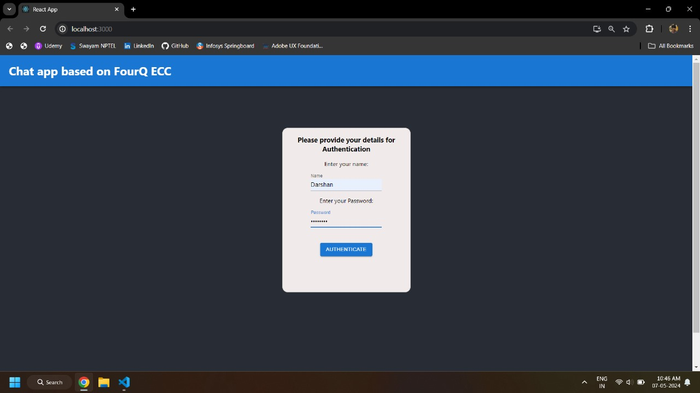

Figure 8.1: Authentication/Login page

The entry point for users to access the chat application. It is where users input their credentials: username and password, to authenticate themselves and gain access to the chat interface.

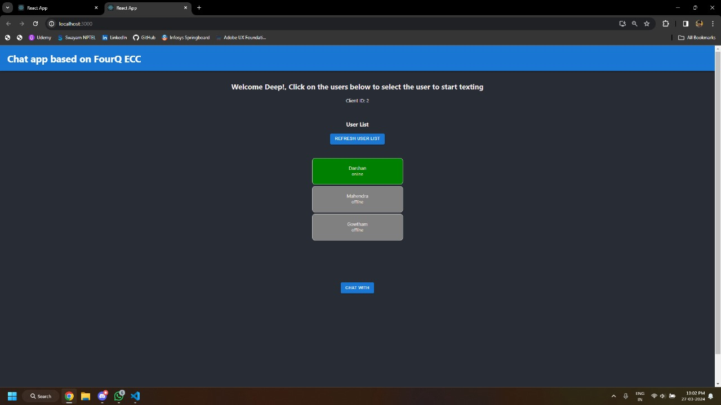

Figure 8.2: User List Page

The user list page in your secure chat application is where users can view a list of other users who are currently online and available for chat. This page serves as a directory of active users and provides users with the ability to initiate new chats or join existing ones.

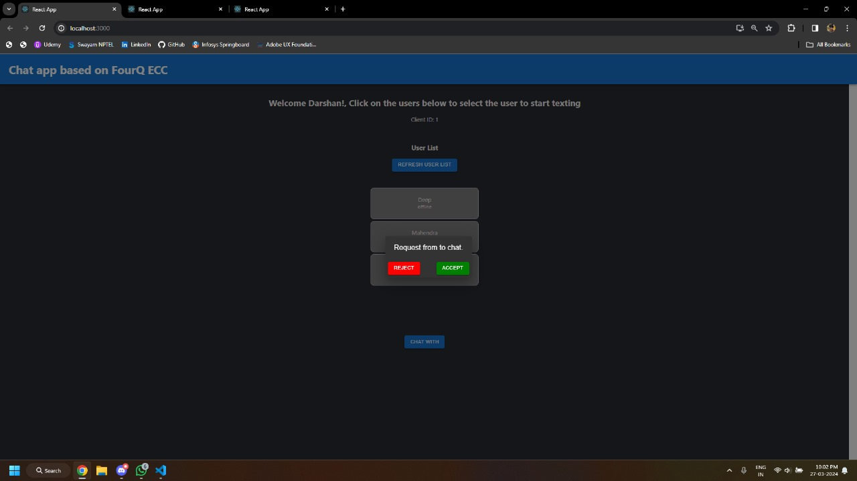

Figure 8.3: When user receives a communication request

When a user receives a communication request, a notification is displayed on the user interface to alert them. The notification typically includes the name or username of the user requesting communication, along with options to accept or decline the request.

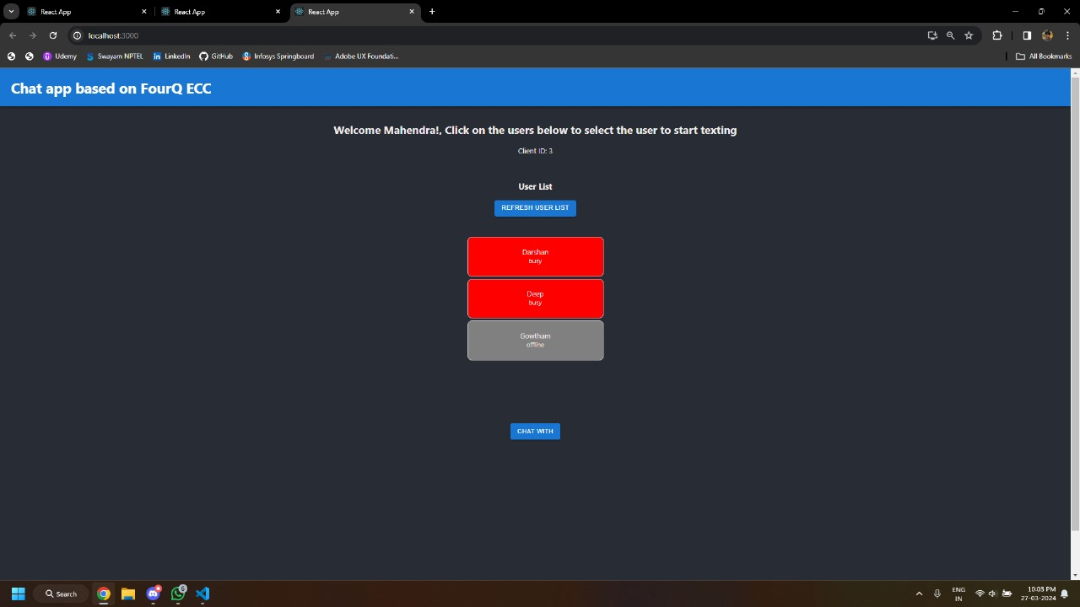

Figure 8.4: Users appear busy when they are chatting to other users.

When a user is engaged in a chat with another user, their status is updated to indicate that they are busy. This helps other users know that the user is currently unavailable for other chats or activities.

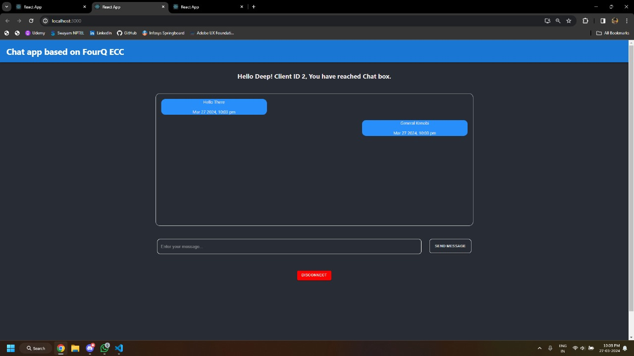

Figure 8.5: communication between two users

During a chat session between two users, messages are exchanged in real-time, allowing for seamless communication. The chat interface provides users with tools to send messages, view message history, and manage the chat session.

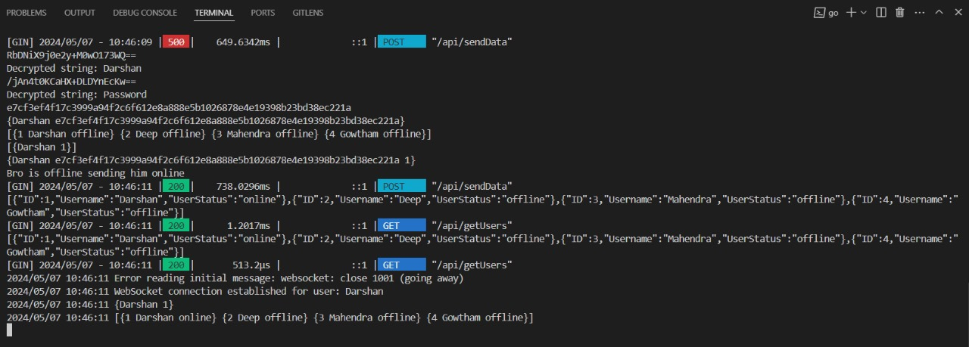

Figure 8.6: The backend handling user authentication

The backend of the chat application plays a crucial role in handling user authentication, ensuring that only authorized users can access the application. The authentication process involves verifying user credentials and managing user sessions.

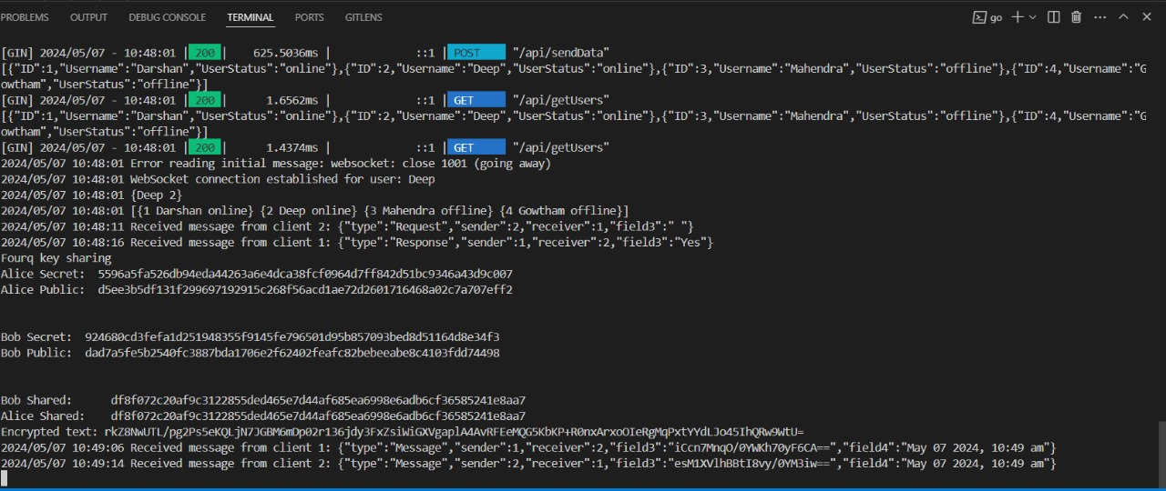

Figure 8.7: The backend handling key generation and message passing

In your project, the backend plays a critical role in generating keys for encryption and facilitating the exchange of messages between users. This figure illustrates how the backend manages key generation and message passing to ensure secure communication.

**APPENDIX B:**

**PAPER PRESENTED IN INTERNATIONAL CONFERENCE**

